

**INTERNATIONAL UNIVERSITY - HO CHI MINH CITY**

**VIETNAM NATIONAL UNIVERSITY**

**PROJECT – Snake Game**

**C/C++ PROGRAMMING IN UNIX**

***Date****: February 25th, 2020*

***Lecturer****: Tran Thanh Tung*

***Members****:*

1. *Pham Hoang Minh - ITITIU19031 (Leader)*
2. *Tran Minh Quang - ITITIU19192*
3. *Truong Nhat Minh Quang - ITITIU19194*
4. *Ha Minh Khoa - ITITIU19020*

***TABLE OF CONTENTS***

1. Members 2
2. Library 2
3. Food 2
4. Additional Features 2
5. Music 2
6. Game Status 2
7. Game Mode 2
8. Score database 4
9. Work Distribution 4
10. Recommendations 5
11. Citations 6

---ooo---

1. ***MEMBERS:***
2. Phạm Hoàng Minh - ITITIU19031 (Leader) (30%)
3. Trần Minh Quang - ITITIU19192 (70% / 3 ~ 23.33%)
4. Trương Nhật Minh Quang - ITITIU19194 (70% / 3 ~ 23.33%)
5. Hà Minh Khoa - ITITIU19020 (70% / 3 ~ 23.33%)
6. ***LIBRARY***

In order to complete this Snake Game, we are highly appreciated the use of SFML library. Therefore, we derive strong credit to the team who has coded this library.

1. ***FOOD***

There are three type of food in this game which are apple, melon and strawberry which is scored two (2), five (5) and ten (10), respectively.

1. ***ADDITIONAL FEATURES***
2. Music

In this game, we have selected six songs that are suitable with this game to boost efficiency: Those song are: Two Steps from Hell – Victory, Fade (Hell's Speaker Remix) Ft.Isabel Park - Alan Walker inspired, Khẩu thị tâm phi Remix, Move Your Body - Ria - Alan Walker Remix, N30N - Speed Nightcore, and a song with name is being unknowned. Moreover, they can choose to pause or replay that music again without causing troubles.

1. Game Status

We totally understand that when users are playing a game but having an immediate trouble to solve. In order to tackle this situation, we have included the Pause, Replay, Restart, Mode Changing, and Exit button to solve all of those troubles.

1. Game Mode:

By using five different functions with multiple of sub-functions, this game contains six different accessible Game Mode which is Single Easy, Single Hard, Single Brutal, Double Easy, Double Hard, and Double Brutal where users can either choose to play alone or with friends. However, in order to clarify the difference between the Easy Mode, Hard Mode, and Brutal Mode, we have changed the delay variable, game rules and obstacles

Delay variable is the most important variables in determining the speed of snake. In the Easy Mode, the speed of the Snake is determined as:  whilst in the Hard Mode, delay is equal to  and  in Brutal Mode

|  |  |  |  |
| --- | --- | --- | --- |
| Time Passed (s) | Delay (s) in Easy Mode | Delay (s) in Hard Mode | Delay (s) in Brutal Mode |
| 0 | 0.15 | 0.1 | 0.1 |
| 30 | 0.1425 | 0.09 | 0.09 |
| 60 | 0.1353 | 0.081 | 0.0729 |
| 90 | 0.1286 | 0.0729 | 0.0656 |
| 120 | 0.1221 | 0.0656 | 0.0531 |
| 150 | 0.116 | 0.059 | 0.0478 |
| 180 | 0.1102 | 0.0531 | 0.0387 |
| 240 | 0.0995 | 0.0478 | 0.0282 |
| 300 | 0.0898 | 0.0348 | 0.0205 |
| 450 | 0.0694 | 0.0205 | 9.847 x 10-3 |
| 600 | 0.0537 | 0.0121 | 4.239 x 10-3 |
| 900 | 0.0323 | 4.239 x 10-3 | 8.728 x 10-4 |
| 1200 | 0.0193 | 1.478 x 10-3 | 1.797 x 10-4 |
| 1500 | 0.0115 | 5.154 x 10-4 | 3.700 x 10-5 |
| 1800 | 6.91 x 10-3 | 1.797 x 10-4 | 7.618 x 10-6 |
| 2100 | 4.137 x 10-3 | 6.266 x 10-5 | 1.568 x 10-6 |
| 2400 | 2.477 x 10-3 | 2.185 x 10-5 | 3.229 x 10-7 |
| 2700 | 1.483 x 10-3 | 7.617 x 10-6 | 6.649 x 10-8 |
| 3000 | 8.881 x 10-4 | 2.656 x 10-6 | 1.369 x 10-8 |
| 3300 | 5.317 x 10-4 | 9.261 x 10-7 | 2.818 x 10-9 |
| 3600 | 3.184 x 10-4 | 3.229 x 10-7 | 5.803 x 10-10 |

*Table 1: The table compares the speed of Snake in term of “delay” variable in three Game Modes*

In terms of game rules, whilst in Easy Mode, Snake can choose to pass the wall if they want or not, in terms of Hard Mode, Snake cannot pass the wall, or bite another Snake (in Double Hard Mode). But in Brutal Mode, Snake cannot pass the wall, bite himself or another Snake

Observing the Obstacle point, although Snake in both Game Modes are died if hitting the Obstacle, in Easy Mode, each 35 seconds passed, the number of obstacles increases by a value of 10. Meanwhile, the number of obstacles increases by a value of 30 after 45 seconds passed. However, in the Brutal Mode, the number of obstacles is equal to  after 60 seconds.

|  |  |  |
| --- | --- | --- |
| Time Passed (s) | Delay (s) in Brutal Mode | Number of Obstacles (Theoretical) |
| 0 | 0.1 | 10 |
| 60 | 0.0729 | 17 |
| 120 | 0.0531 | 30 |
| 180 | 0.0387 | 53 |
| 240 | 0.0282 | 93 |
| 300 | 0.0205 | 164 |
| 360 | 0.015 | 287 |
| 420 | 0.0109 | 502 |
| 480 | 7.977 x 10-3 | 879 |
| 540 | 5.815 x 10-3 | 1539 |
| 600 | 4.239 x 10-3 | 2639 |

*Table 2: The table shows two most important features in the Brutal Mode*

* Some obstacles can be repeated so the factual number of obstacles is smaller than the theoretical one.

1. Score Database:

If users keep playing the game around one or two hours, they want to achieve some extent of satisfaction through score comparison. That is why we have set up function when users can check their points after playing a set. However, we do not store the score if users shut the game down as some articles points out if the score is being stored, player will continue playing over and over which decrease the working efficiency and attention, causing insomnia and headache.

1. Bonus Time:

After 75 seconds in silence, there are 150 fruits available on the screen (theoretical) on the screen for 15 seconds before disappearing. However, this bonus time can cause annoying death if players does not pay attention.

The score and Snake’s Length incrementation are doubled at Apple and Melon but in terms of Strawberry, the score and Snake’s Length decrease level will be minus five times at usual.

1. ***WORK DISTRIBUTION:***

#1: Trần Minh Quang is the one who make GUI and How to play (Difficulty Level: 3.5 – 5 /10). Therefore, he can only gain 23% of score over the total as the leader have already taught him two (02) full lessons about the SFML Libraries and all of the possibilities and events to create one with full functions.

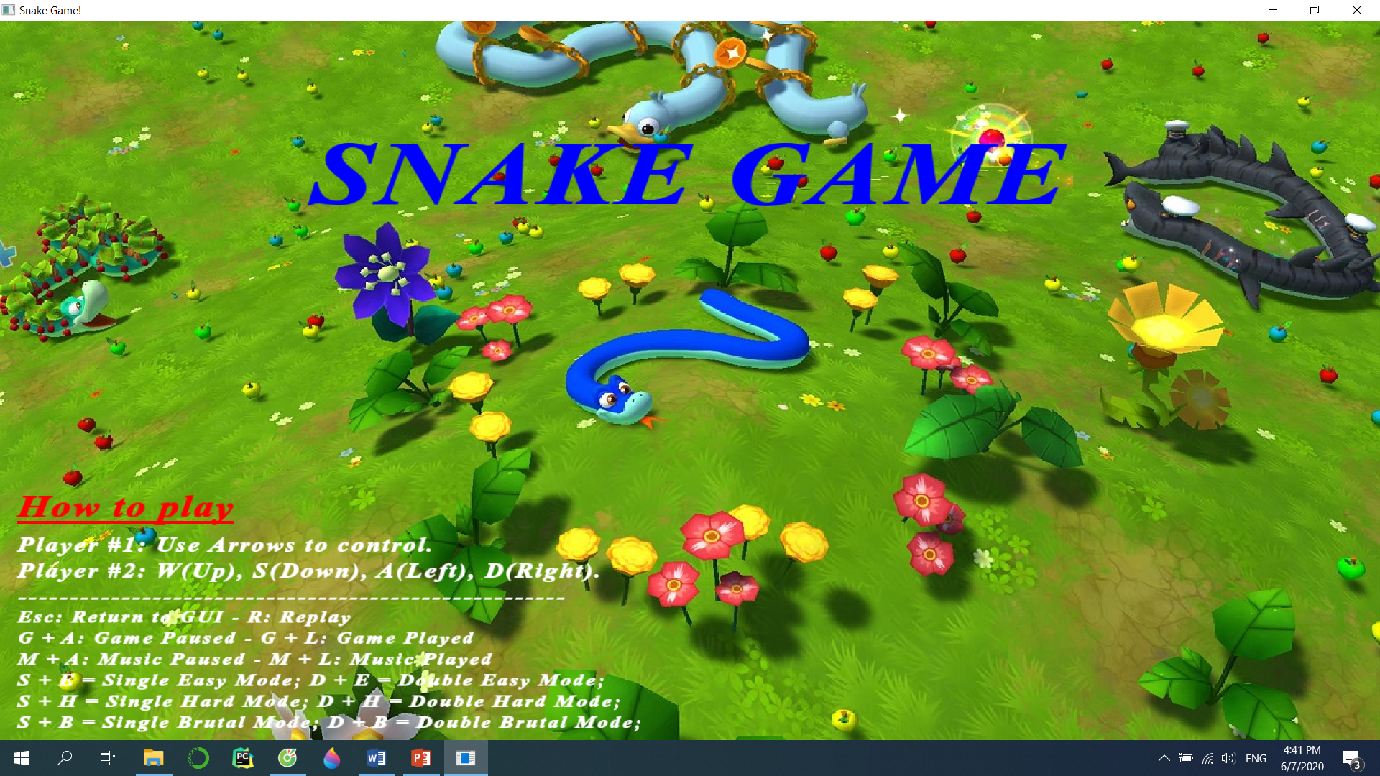

*Figure 01: The Cover of the Game*

#2: Trương Nhật Minh Quang is the one who make GameMode (both Easy and Hard) with Obstacles only (Difficulty Level: 3/10). Therefore, he can only gain 23% of score over the total as the leader have presented sample codes of Easy Mode already and he only needs to create the Hard Mode which is based on my Easy Mode code already.

#3: Hà Minh Khoa is the one who make “Replay” function, add Music when played, and Ended “Window” (Difficulty Level: 3/10). Therefore, he can only gain 23% of score over the total as the leader have already taught him two (02) full lessons about the SFML Libraries and all of the possibilities and events to create one with full functions.

#4: Phạm Hoàng Minh is the one who re-create the code, propose ideas, add more music, merge all of the discrete code from above, initialize the random for both Obstacles and Fruit, set up four other GameMode (Single Brutal and all Double Mode) for players which are used for two players playing at the instance, and push up TeamMembers. Thus, as those tasks involved require large attention with ideas (with high difficulty ranging from 9 to 9.5), he can gain 30% of score over the total.

1. **RECOMMENDATIONS**

In order to achieve highest level of satisfaction:

* A personal computer (PC) or laptop is a must.
* You must have the ability of counting time, guessing Obstacles, and tricking partners (you have to be smart if you played in Double Mode)
* You have to be patient at all time.
* You must have high luck. Do not overuse your lucky point overwhelmed.
* You have already known the rules thoughtfully.
* You have to experience Easy Mode at the first trial (Three to five times for sure) before trying at Hard Mode or Brutal Mode. You have to pass at least three to five times with at least five (05) minutes each at Easy Mode before reaching to Hard Mode, and at least three to five times with at least three (03) minutes each at Hard Mode.

1. **CITATIONS**
2. SFML Library <https://www.sfml-dev.org/license.php>
3. Git-Hub: <https://github.com/IchiruTake/Snake-Game-at-IU>